 | ABCAUS AUTO EXCEL SALARY TDS CERTIFICATE FORM 16

Macros

Macros must have been enabled to use this form. If you are not aware of how to enable macros in Excel , you can download a help file on how to enable macros from home page http://abcaus.in

How to use this form

The whole form has been divided into four sections. Each section can filled through fill button provided in each section.

Fill Buttons |  | 

Use these buttons to fill each section of the form. Alternatively, after filling each section it prompts for proceeding to the next section:

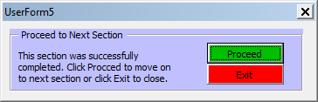

After all sections have been filled up, Excel Form 16 is ready for printout.

Please note that allowable deductions under Chapter VIA and Income Tax is computed automatically in Excel Form 16.

Resetting/Modifying Values

- If after filling any one section or all section, a correction is needed, click on fill button and fill only the field for which correction is required and click on green “fill excel form 16” button
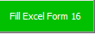 It would make the correction in only the field required.

- For resetting the fields of a fill form, click on pink “Reset this fill form” button. 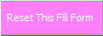 It would reset the fields of the open fill button.

- For resetting the Excel Form 16 for preparing a fresh form, click on the red “Reset Excel Form 16” Button
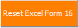 This will reset the fields in Excel sheet to blank.

Feel free to contact me if you have any query or problem in using this utility.

CA Ashutosh Lohani
info@abcaus.in
http://abcaus.in

